Problem Description:
The VPN client fails to connect to my gateway. When I click on connect,
the client application reports that a negotiation timed out occurred. This VP Client does not work on an XP SP3 Desktop either. When I attach a D-Link DSL504G/AU modem/router it works fine however I need the wireless capabilities of this Belkin. I contacted the support at Belkin and they say I may need changes to the config of the Shrew Software in order for it to work.
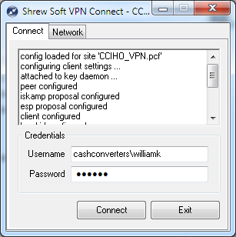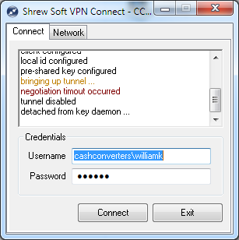
OS Version:
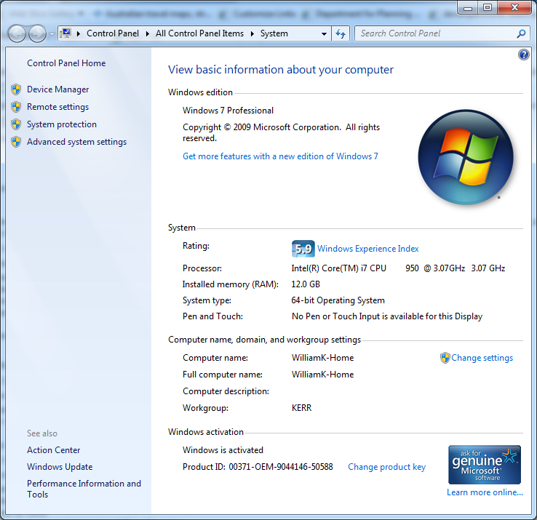
Gateway information: Belkin F6D4630-4 V1
The firmware for the Belkin is : F6D4630-4_WW_1.00.05
VPN Client Version: 